Tongue Drum Player

Introduction
Denis Santerre
&
Fawwaz Hazzazi

The idea of this came from the player piano but using a raspberry pi to play a tongue drum. The input was to be a file which acted like the paper roll of piano player. We also added a Wii-Nunchuck as an interaction device. Third we added a randomizer which would act like wind chime.

This report will focus mainly on the Wii-Nunchuck version which is the most complex of the the three.

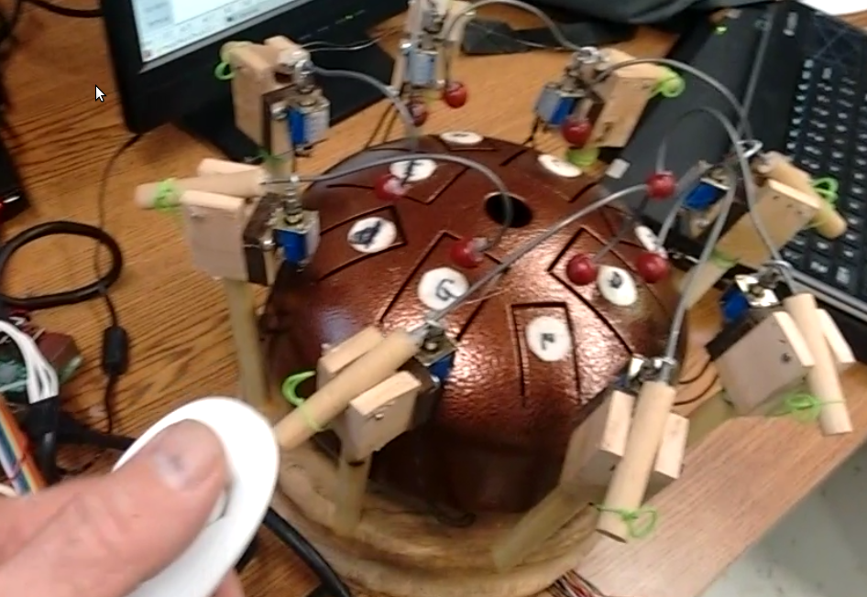

Hardware

Raspberry Pi
8 solenoids
8 channel relay board
Wii-Nunchuck
8 hammers (Fabricated)
Tongue Drum
Stand (Fabricated)

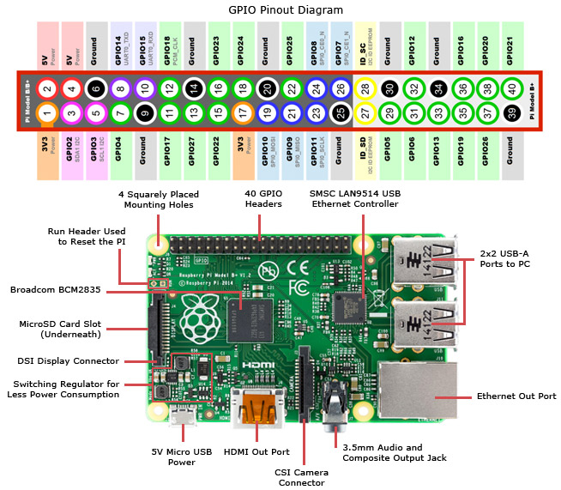
Raspberry Pi
We used the Raspberry Pi 3 although any Raspberry Pi would work. The GPIO pins would be different with the older Rpis.
Raspberry Pi3

1.2GHz 64-bit quad-core ARMv8 CPU
More than adequate
1GB RAM
More than adequate
802.11n Wireless LAN
Helpful when programming using ssh
Ethernet port
Helpful when programming using ssh

Power
Manufacturer recommended 2.5 amp supply because of high current USB devices. We used standard 0.5 amp supply.

GPIOs
There are over 20 GPIOs availably for the hammers. We used 8 GPIO for the drum hammers and 2 i2c GPIOs for the nunchuck. The Rpi used a Rasbian OS.

SD card
16 gB class 10

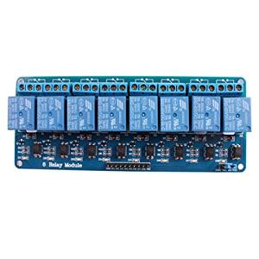
8 channel relay board
The relay board has 8 mechanical relay. They are powered by 5 volts which is pulled from the Rpi board. This must be considered when selecting the Rpi power supply.

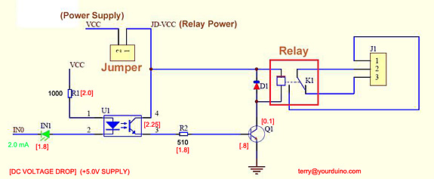

Solenoids
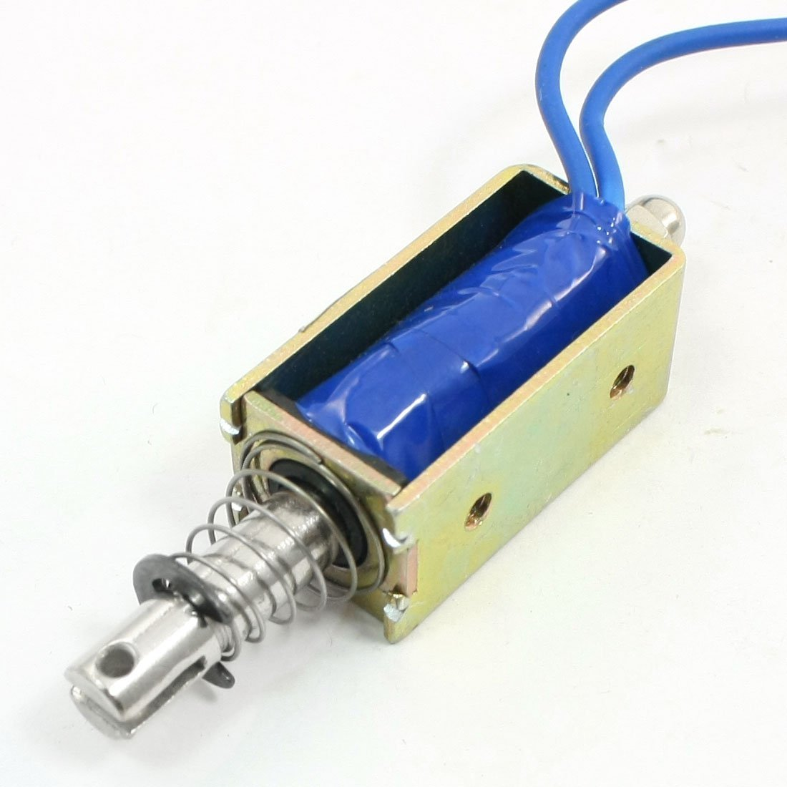
The solenoids are powered by a separate 12 volt power supply. They are rated at 0.3 amps holding current but would draw 1 amp when supplied 12 volts.

Wii-Nunchuck
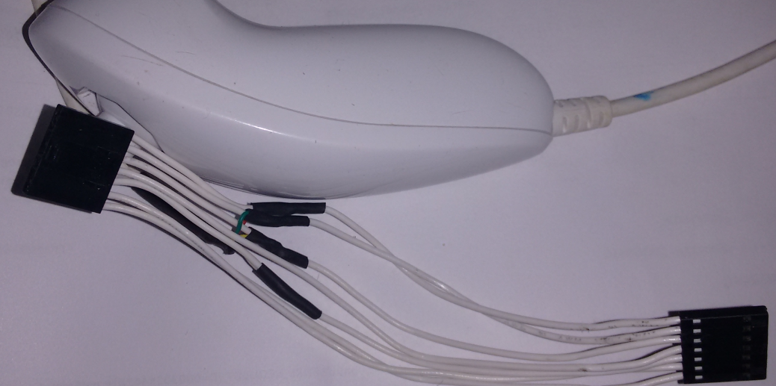
The Wii-Nunchuck is a i2c device. The plug of the Wii-Nunchuck was removed and replaced with a computer interface cable. The V3.3 SDA, SCK, and GND was spliced so the plug would connect to the Rpi header at pins 1, 3, 5, and 9.
All seven wires had 2 female ends. One end could plug directly to the Rpi header and the other end would have 7 females connectors for future use.

Hammers

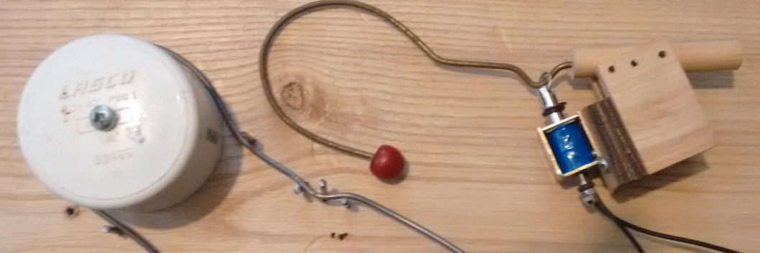
The hammers were made with spring wire which is very hard to bend. Clothes hanger wire should work as well and is easier to bend. A jig can be made to make the bend. The bend was made to create a bounce to the hammer so the tongue would vibrate and not be muffled.

Tongue Drum

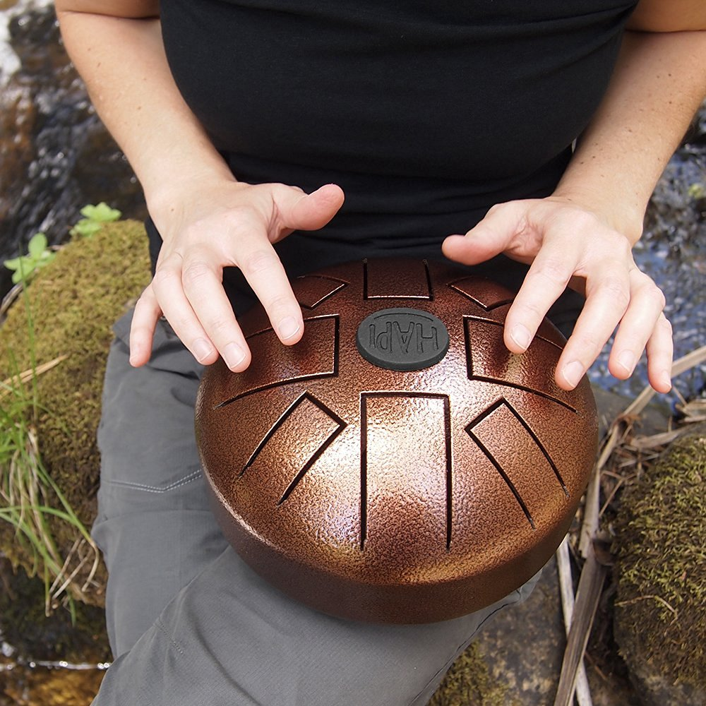
The Tongue Drum is a percussion instrument in a pentatonic scale. It has 8 notes and is usually played with the hands/fingers or with mallets. It comes with different scales.

Software
We used C code because the course was based around C. I had little experience with the language before I started the course and I wanted to become more familiar with it. I had made a statement in class that the language I was most familiar with was Basic programming from 1984 which I said probably wouldn’t work. I have since found out that it would work. Knowing that I still prefer having used C. We could have used python which may have been easier in the short run.

We also used the wiringPi library. We could have used assembly as well. We felt wiringPi is more appropriate for the casual user.

We also used easyABC as a music writed program. It produces a text file in the format of “A/ B// C d// e G.” The letters correspond to the notes and the / correspond to the duration.

Real Time
There is no hard real-time issues. The soft real-time issue would create music with timing be off.
The firm real-time issue would create music with notes missing. Both soft real-time and firm real-time would create music which may be unpleasant to listen to. We chose the pentatonic scale because the notes can be played at random and with random timing and the sound is still pleasant. This would be like the sound of wind chimes. If the randomizer code is run than any soft real-time or firm real-time issue would be indistinguishable from no issue.

Security

There is no security issue under the intended use. It is not connected to the Internet except during programming. In the future it could be connected to the Internet. If it was connected to the Internet it is potentially possible for a malicious person to cause all relays to come on as the same time creating a fire hazard by over loading the power supply.

Relate Work

Music boxes and mechanical music machines have been around for a long time. The coo-coo bird clocks were the pride of the creators. Wind chimes are a popular summer joy. Moving the music box into new technology may be considered either moving forward or a crime to tradition. Most electronic music generation is synthesized music. We have not found any project instructions like the one we have done.

Future Work

A number of future projects are available. A different instrument could be used such as wine glass with water. The glasses could be tuned using water so any song using 8 notes or less could be played. An interaction unit could be installed at the local children’s museum as other projects from UMO have done

- We might use electromagnetic instead of the solenoids.
- We would use the Wii-nunchuck not only to control the speed the playing but also to associate a certain tone to every direction.
- Getting some sort of input by using wifi.

Conclusion
We didn’t divide the work between us before we began. We individual and together worked on problems as they came up until were solved. However, if it’s necessary, I would say the code part was mostly the work of Denis. He tried to create and collect codes. Then, making sense of it to make it ready for implementation on our player. The hardware connections of the GPIOs, solenoids, and relays was Fawwaz tasks. The idea of using mechanical relays was based on Denis experience then adding the external source. The power calculation of the circuit and the preparing of the presentation were mostly Fawwaz’s tasks. We attended a workshop for using Universal Versa Laser machine in the electronics and cutting laser lab. We tried several prototypes for the base and hammers of our prototype until we come with current one.

Challenges
- Making sure that we isolated the GPIOs from the external source.
- Creating and designing a method to make the sound of hammers more pleasant.
- Using the wii-nunchuck as an input to the players

- We might use electromagnetic instead of the solenoids.
- We would use the wii-nunchuck not only to control the speed the playing but also to associate a certain tone to every direction.
- Getting some sort of input by using wifi.
- The project could go into the local children’s museum were other projects from UMO has gone.

Appendix

You can see a video of the tongue drum player being controlled with the Wii-Nunchuck at
https://www.youtube.com/watch?v=5xSOetzYEvc
Here is a video of our presentation.

https://www.youtube.com/watch?v=bs_DrFDXa-I&t=23s

WiringPi library can be found at

http://wiringpi.com/

You will need to get a version that is compatible with c code if you decide to duplicate the project.

Vince Weaver, the professor, may put a summary of this and other projects on the course, University of Maine ECE 471, website.

